Blahtech Supply Demand

Supply Demand uses previous price action to identify potential imbalances between buyers and sellers. The key is to identify the better odds zones, not just the untouched ones.
Blahtech Supply Demand indicator delivers functionality previously unavailable on any trading platform. This 3-in-1 indicator not only highlights the higher probability zones using a multi-criteria strength engine, but also combines it with multi-timeframe trend analysis and previously confirmed swings. Driven by an easy-to-use interface and innovative backtest mode this indicator is a must-have for all supply demand traders.

Feature Highlights
- Multi-timeframe display
- Backtest directly on the chart
- Summary panel
- Multi-timeframe trend analysis
- Confirmed swings (high and low QPoints)
- Zone strength engine (seven criteria with user defined mode)
- Advanced level detection (peaks, consolidations, drop-base-drops)
- Quarterly and Yearly levels
- Control of overlapping levels
- Configurable level information
- Fast access hot-keys
- Alerts
- Engulfing detector - Multi-timeframe
- Visibility Filters (User customisable)
- Old zones / Flip zones (broken levels or trend changes)
- Highlight of Nested zones

Input Parameters
Blahtech Supply Demand indicator is fully customisable. The input parameters are separated into sections
- Expert Advisor Mode
Reserved for iCustom calls from an Expert Advisor. Code examples available on request
- Min Bars Level
Set the minimum bars that have to exist for a level to be created (2 bars or more)
- Max Bars
Set the max bars to be used for the calculations (0 = all available bars)
- Force Recalc Bars (default 1000)
Set the number of bars before forcing a full recalculation. This indicator uses incremental calculations for each bar to dramatically reduce CPU load. This parameter can be used to fine tune expert advisor’s performance and memory
0 - Always Incremental
1 – Force full calculation each bar
n – Force full calculation every “n” bars

======== Solo Timeframe 1 ========
By default, the SD indicator displays the levels for the current timeframe only. The colours and styles for this mode can be set separately from the multi-timeframe display modes (Timeframes 1,2,3 below)
- Zone Style
Choose the draw style for the solo timeframe boxes on the chart
Solid, Line, Dash, Dotted, Dash-dotted, Dash-dot-dash
- Supply Colour Strong
Colour for the solo strong supply levels
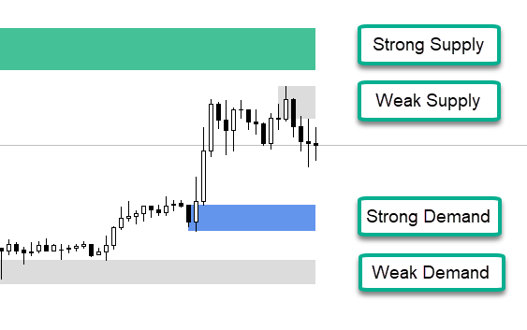
- Supply Colour Weak
Colour for the solo weak supply levels
- Demand Colour Strong
Colour for the solo strong demand levels
- Demand Colour Weak
Colour for the solo weak demand levels
- Colours – Auto defaults
Change default colours for backgrounds and styles. This uses slightly darker colours for black backgrounds and also a simpler two-tone colour scheme for solid zone style. (Default true)

========= Timeframe 1 =========
- Visible
Show / hide timeframe 1 boxes on the chart. The “Solo” timeframe settings are used when this is the only timeframe visible. When there are multiple timeframes visible these settings then take effect.
Hot-key: This can be changed without bringing up the parameters with the “1” key
- Timeframe
Choose the period for Timeframe 1
- Current
- Mapped (Use the Timeframe map to lookup the timeframe)
- Current Plus One (One timeframe up from the current timeframe)
- Current Plus Two
- Current Plus Three
- (6..12) M1 => Y1
- Timeframe Map
When Timeframe is set to Mapped Mode - Lookup the period using the current timeframe as a key
- Zone Style
Choose draw style for the boxes
- Zone Line Width
Width of the lines around the level boxes
- Supply Colour Strong
Colour for the strong timeframe 1 supply levels
- Supply Colour Weak
Colour for the weak timeframe 1 supply levels
- Demand Colour Strong
Colour for the strong timeframe 1 demand levels
- Demand Colour Weak
Colour for the weak timeframe 1 demand levels

========= Timeframe 2 =========
- Visible
Show / hide timeframe 2 boxes on the chart
Hot-key: This can be changed without bringing up the parameters with the “2” key

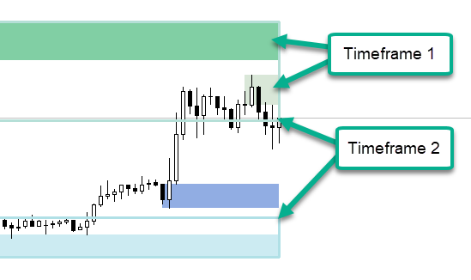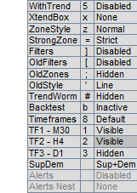
- Timeframe
Choose the period for Timeframe 2
- Current
- Mapped (Use the Timeframe map to lookup the timeframe)
- Current Plus One (One timeframe up from the current timeframe)
- Current Plus Two
- Current Plus Three
- (6..12) M1 => Y1
Timeframe Map
When Timeframe is set to Mapped Mode - Lookup the period using the current timeframe as a key

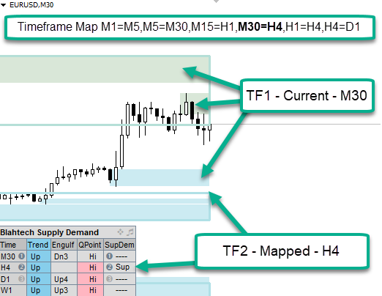
- Zone Style
Choose draw style for the boxes
- Zone Line Width
Width of the lines around the level boxes
- Supply Colour Strong
Colour for the strong timeframe 2 supply levels
- Supply Colour Weak
Colour for the weak timeframe 2 supply levels
- Demand Colour Strong
Colour for the strong timeframe 2 demand levels
- Demand Colour Weak
Colour for the weak timeframe 2 demand levels

========= Timeframe 3 =========
- Visible
Show / hide timeframe 3 boxes on the chart
Hot-key: This can be changed without bringing up the parameters with the “3” key
- Timeframe
Choose the period for Timeframe 3
- Current
- Mapped (Use the Timeframe map to lookup the timeframe)
- Current Plus One (One timeframe up from the current timeframe)
- Current Plus Two
- Current Plus Three
- (6..12) M1 => Y1
- Timeframe Map
When Timeframe is set to Mapped Mode - Lookup the period using the current timeframe as a key
- Zone Style
Choose draw style for the boxes
- Zone Line Width
Width of the lines around the level boxes
- Supply Colour Strong
Colour for the strong timeframe 3 supply levels
- Supply Colour Weak
Colour for the weak timeframe 3 supply levels
- Demand Colour Strong
Colour for the strong timeframe 3 demand levels
- Demand Colour Weak
Colour for the weak timeframe 3 demand levels

========= Timeframe 4 =========
- Timeframe
Choose the period for Timeframe 4 used in the summary display and trend analysis
- Current
- Mapped (Use the Timeframe map to lookup the timeframe)
- Current Plus One (One timeframe up from the current timeframe)
- Current Plus Two
- Current Plus Three
- (6..12) M1 => Y1
- Timeframe Map
When Timeframe is set to Mapped Mode - Lookup the period using the current timeframe as a key

========== Q Points =========
- QPoints 1
Display high low swing points on the chart.
1) Hidden
2) Timeframe 1
3) Timeframe 2
4) Timeframe 3
5) Timeframe 4
6) 1 Minute
7) 5 Minute
8) 15 Minute
…
14) 1 Month
15) 1 Quarter
16) 1 Year
Hot-key: This can be changed without bringing up the parameters with the “Q” key

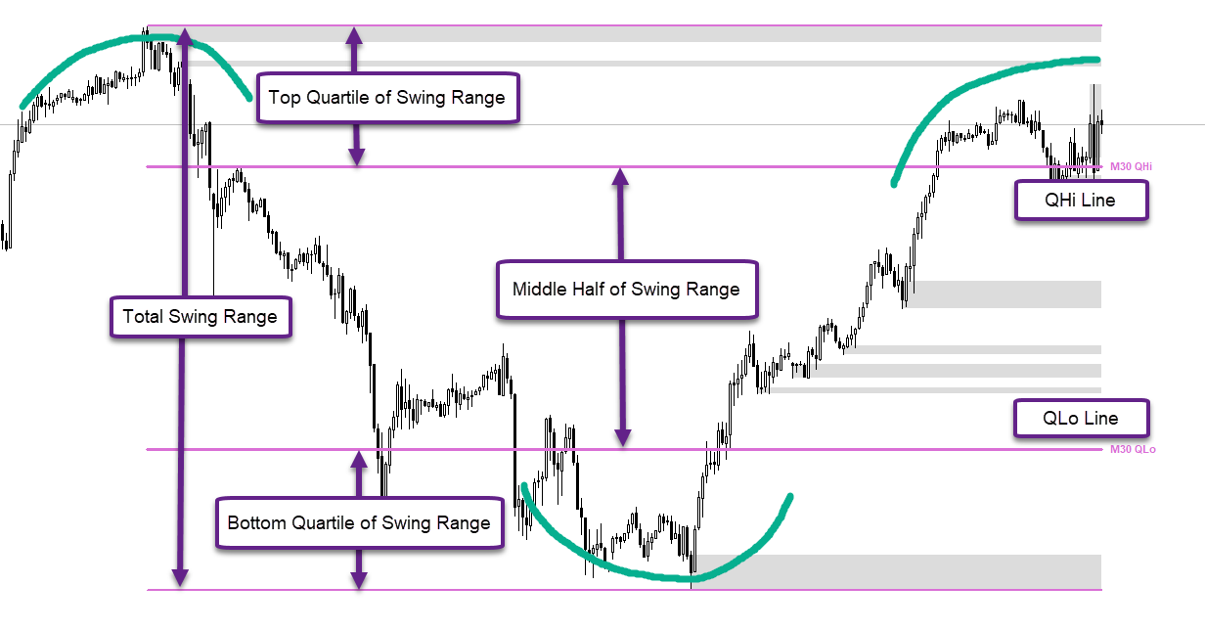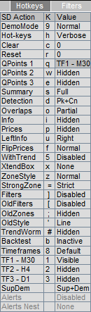

- QPoints 2
Display a second set of high low swing points on the chart.
1) Hidden
2) Timeframe 1
3) Timeframe 2
4) Timeframe 3
5) Timeframe 4
6-16) 1 Minute => 1 Year
Hot-key: This can be changed without bringing up the parameters with the “W” key
- QPoints 3
Display a third set of high low swing points on the chart.
1) Hidden
2) Timeframe 1
3) Timeframe 2
4) Timeframe 3
5) Timeframe 4
6-16) 1 Minute => 1 Year
Hot-key: This can be changed without bringing up the parameters with the “E” key
- QPoints - Show Text
Display QHi and QLo text to the right of the levels
- QPoints – Min Range (Avg Bar Size)
Set the minimum size for a valid swing. Default 6.0 (times average bar size)

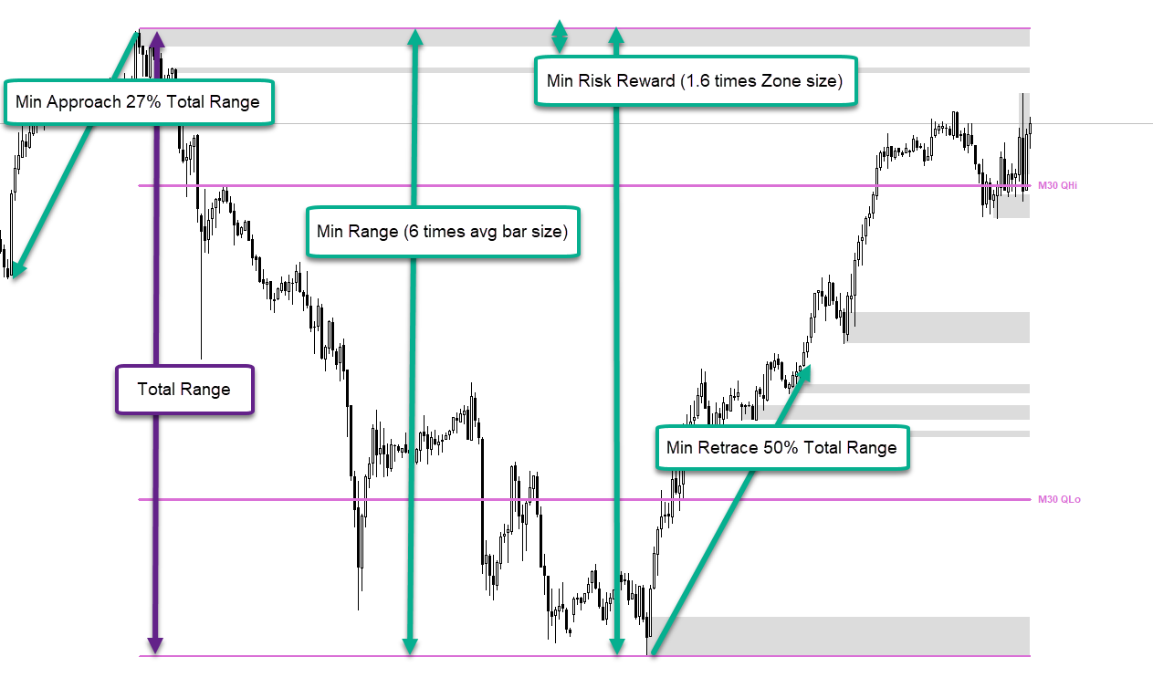
- QPoints – Min Retrace (QPoint Range)
Set the minimum size the swing must retrace before it can be considered a new swing. Default 0.5 (50%)
- QPoints – Min Approach (QPoint Range)
Set the minimum size of the approaching peak for it to be considered a fresh swing rather than a continuation of a previous swing. Default 0.27 (27%)
- QPoints – Max Highlight (Avg Bar Size)
Define the max size of a QHi/QLo swing that gets highlighted in Pink/Blue in the Summary Panel. A swing that is too big is likely aligned with a higher timeframe will be displayed with a grey background instead. It will also be marked with purple text on the chart instead of the usual pink colour. Default 15.0

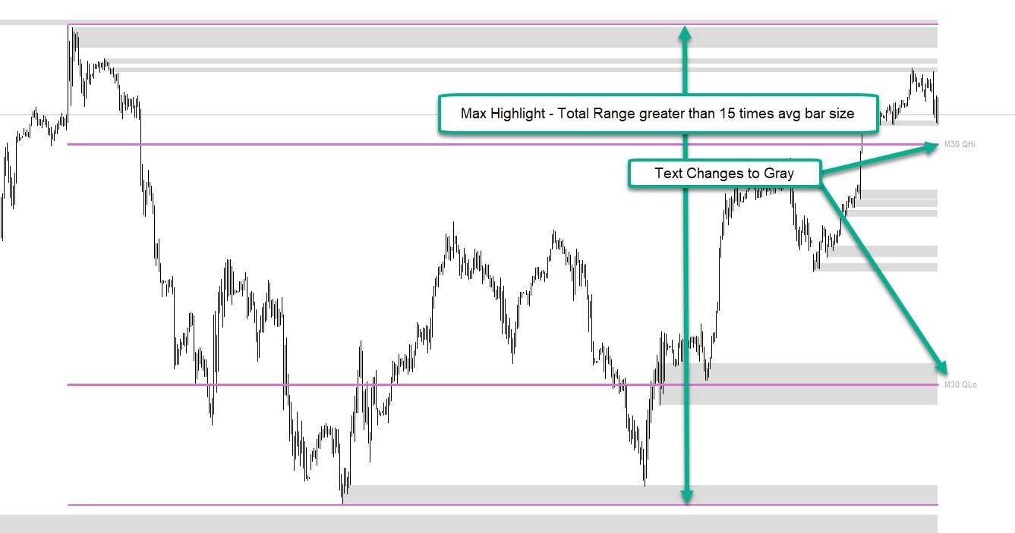
- QPoints – Min Risk Reward
Set the risk reward ratio for a level to be considered significant enough to be a new swing. Default 1.6
- QPoints – Chart Colour 1
Set the colour of the QPoint 1 lines and text on the chart
- QPoints – Chart Colour 2
Set the colour of the QPoint 2 lines and text on the chart
- QPoints – Chart Colour 3
Set the colour of the QPoint 3 lines and text on the chart

======== Summary Panel =========
- Summary
Display the Summary panel on the chart.
1) Hidden
2) Compact
3) Full
4) Full with Alerts
Hot-key: This can be changed without bringing up the parameters with the “S” key

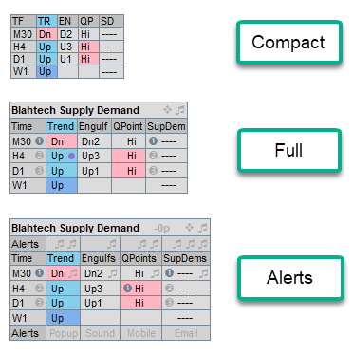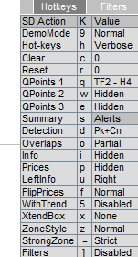

- Timeframes
Display extra timeframes in the Summary display dialog
1) No Extra - Just display the 4 default timeframes
2) Fill Gaps - Fill gaps between the 4 timeframes
3) Fill Gaps + Higher - Add all the Higher timeframes
4) Fill Gaps + Lower + Higher - Add all the Lower and the Higher timeframes
5) Fill Gaps + Lower - Add all the Lower timeframes
Hot-key: This can be changed without bringing up the parameters with the “8” key

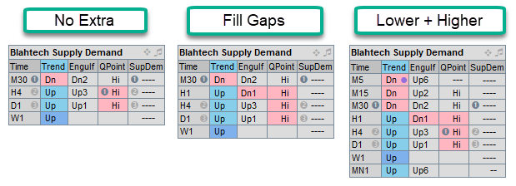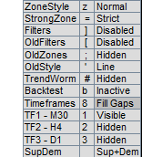
- Timeframes – All
Provide a comma separated list of timeframes names to display when “Fill Gaps + Lower + Higher” is active
- Timeframes – Show Bubble Numbers
Display Bubble Hints for the 1,2,3 levels in the timeframe column as well as the SupDem column
- Engulfings – Show
Show column with recent engulfings for each timeframe.

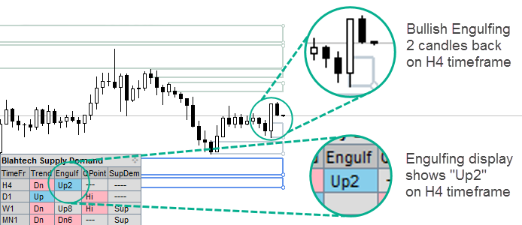

- Engulfings – Num Bars Search
Number of bars to search backwards when looking for recent engulfings
- Engulfings – Min Size (Avg Bar Size)
Minimum size between open and close price for the engulfing to be valid

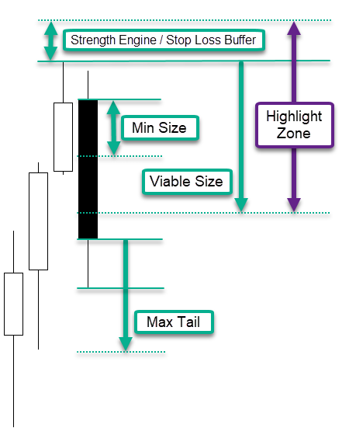

- Engulfings – Max Tail (Avg Bar Size)
Maximum size of tail that is permitted for the engulfing to be valid
- Engulfings – Viable Size (Avg Bar Size)
Set the size of the viable zone. For a bearish engulfing, this is taken from the highest of the engulfing bar or its previous bar. The Highlight zone spans from the stop loss level to this viable level

- Trend Change – Overlaps
Set the type of overlaps that cause the trend to change when broken. Changing to “Overlap None” or “Overlap Partial” will reduce the sensitivity of the trend changes. Default “Overlap All”

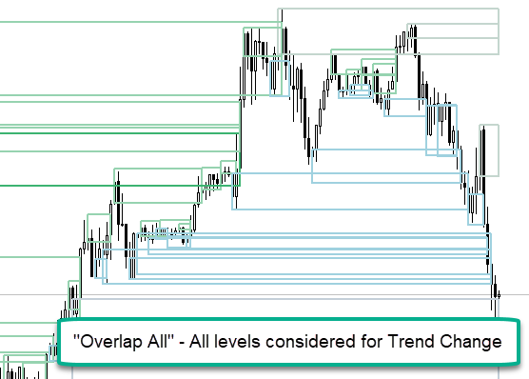

- Trend Change – Detection Mode
Set the type of levels that cause the trend to change when broken. Default “Peaks + Consolidations”
- Trend Change – Detect QPoint Overlaps
Use overlap levels to change the trend when they are at QPoint boundaries. This allows the trend to operate correctly when we have a massive wicky level due to a flash crash or other exceptional event.
- Trend Change – Min Range (Avg Bar Size)
Set the minimum range from price to max move away for the level to be considered significant enough to trigger a trend change. Default 2.5
- Trend Change – Min Risk Reward
Set the risk reward ratio for a level to be considered significant enough to trigger a trend change. Reducing this value will cause more levels to trigger a trend change (Default 1.6)

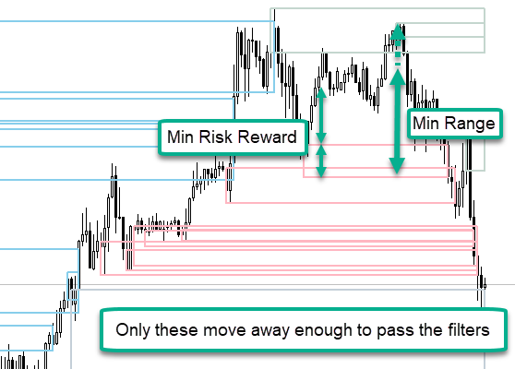
- Trend Change – Overall Trend Method
- Two Adjacent
- Best Of Three
- Current Timeframe
- Three In A Row

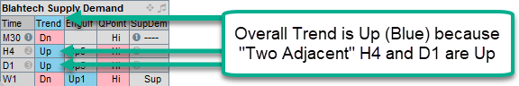

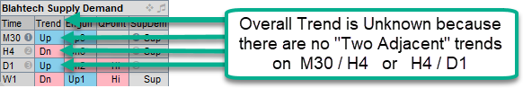

- Trend Change – Extended Trend (Avg Bar Size)
Highlight the trend with a deeper colour when it exceeds this range. Default 15.0

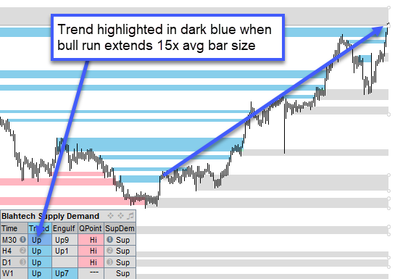

- Trend Change – Show Consolidation Dots
Show a dot in the trend column for each timeframe when a consolidation is detected

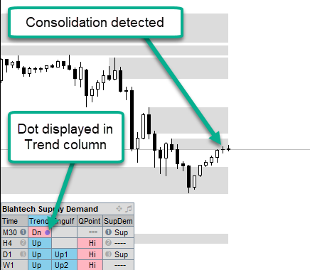
- Trend Change – Worm
Display a Trend Worm on the chart for the current timeframe
- Hidden
- Trend
- Trend + Consolidations
- Consolidations
Hot-key: This can be changed without bringing up the parameters with “#” key

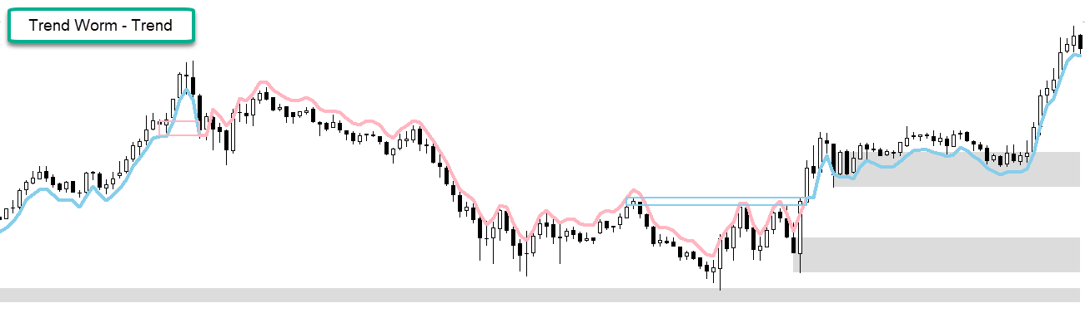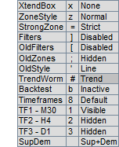

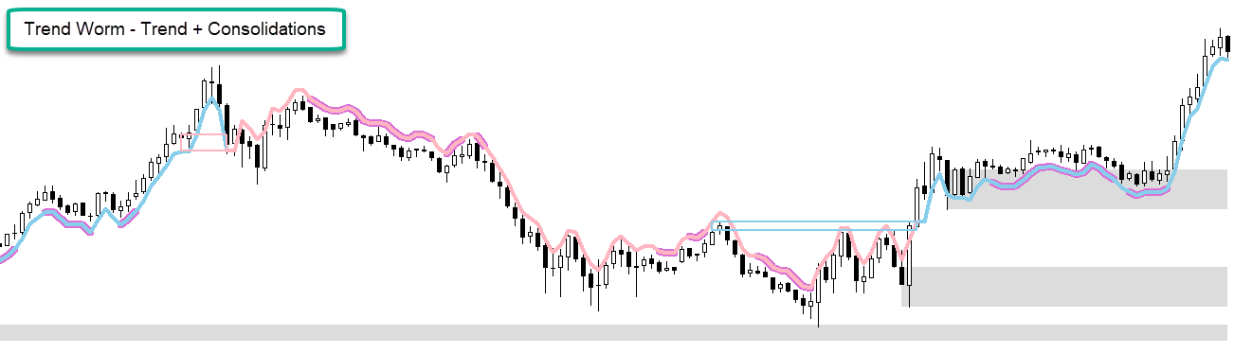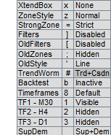

- Trend Change – Worm – Style
Set the line style for the Trend Worm on the chart
- Trend Change – Worm – Thickness
Set the line thickness for the Trend Worm on the chart
- Trend Change – Worm – Colour Up
Set the line colour for the Up Trend changes within the Trend Worm
- Trend Change – Worm – Colour Down
Set the line colour for the Down Trend changes within the Trend Worm
- Trend Change – Worm – Colour Consolidating
Set the line colour for the Trend Worm when it is consolidating
- Trend Change – Worm – Channel Gap Size (Avg Bar Size)
Set the size of the gap between the Up lines and the Down lines
- Highlight SupDem in QPoint – Strength (0-8)
Highlight the SupDem column with SkyBlue/Pink when its strength exceeds this level and it is contained within a QPoint. Default 4

- Summary Panel Text Size
Text size for the Summary dialog
- Summary Panel Position
- Top Left
- Top Right
- Bottom Left
- Bottom Right
- Summary Panel X Offset
Set the position of the panel relative to the left side
- Summary Panel Y Offset
Set the position of the panel relative to the bottom side

========== Hot Keys ===========
- Hot Keys
Show / Hide the Hot-key dialog.
- Hidden
- Hotkeys - Compact
- Hotkeys - Verbose
- Hidden
- Filters - Compact
- Filters - Verbose
Hot-key: This can be changed without bringing up the parameters with “H” key

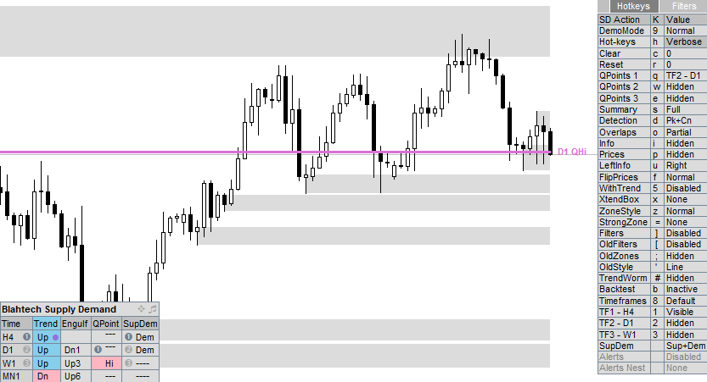

- With Trend Scores
Take account of the overall trend when calculating strength of levels.
- Detection Mode
Select the type of levels that are detected and displayed
- Peaks
- Peaks + consolidations
- Peaks + consolidations + drop-base-drops
Hot-key: This can be changed without bringing up the parameters with “D” key
- Overlaps
Select the type of overlapping zones to display
- Overlaps None
- Overlaps Partial
- Overlaps All
Hot-key: This can be changed without bringing up the parameters with “O” key

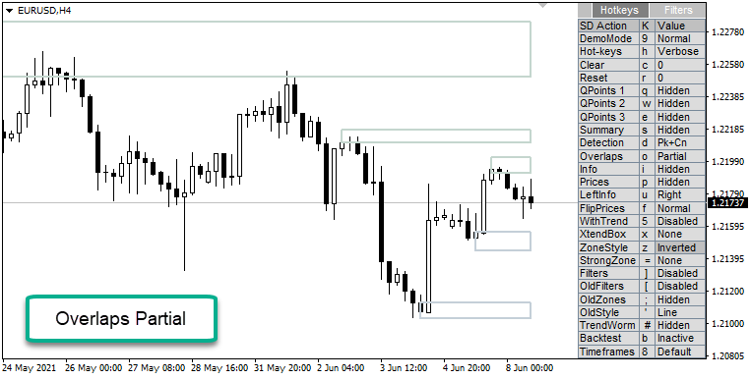

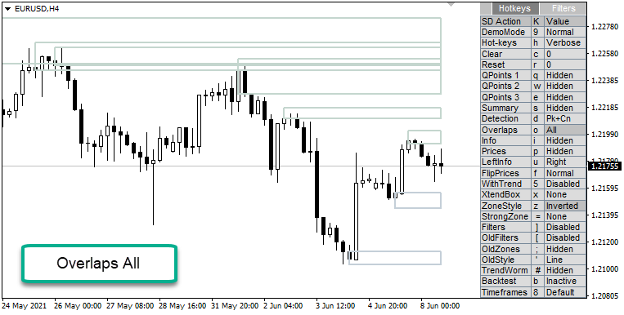

- Info Text
Display text-based information for levels on the chart.
- Hidden
- Score
- Score + Size, Lots
- Score + Size, Lots, Scoring, Avg size
- Score + Date
- Score + Date, Size, Lots
- Score + Date, Size, Lots, Scoring, Avg size
- Score + Custom 1 – User defined string with substitutions
- Score + Custom 2 – User defined string with substitutions
Hot-key: This can be changed without bringing up the parameters with “I” key

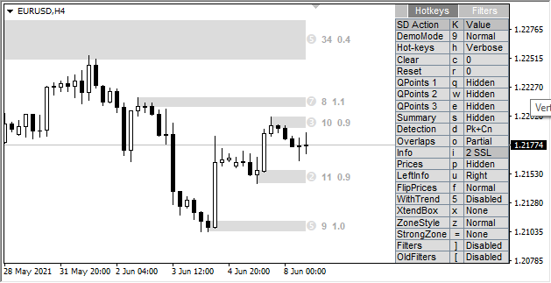
- Prices
Display high and low prices to the right of each level.
- Hidden
- Small
- Large
Hot-key: This can be changed without bringing up the parameters with “P” key

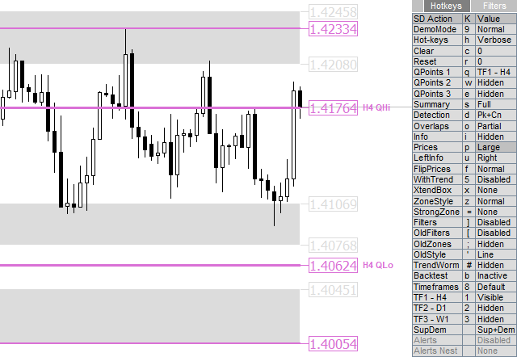

- Left Info
Switch the info text from left to right.
Hot-key: This can be changed without bringing up the parameters with “U” key
- Extend Box Beyond End
Draw the boxes past the final bar so they don’t obscure the candles.
Hot-key: This can be changed without bringing up the parameters with “X” key
- Highlight Nested Zones
Choose the graphic type at right corners of each level when they are nested within higher timeframe zones
- Hidden
- Corner Points
- Corner Lines

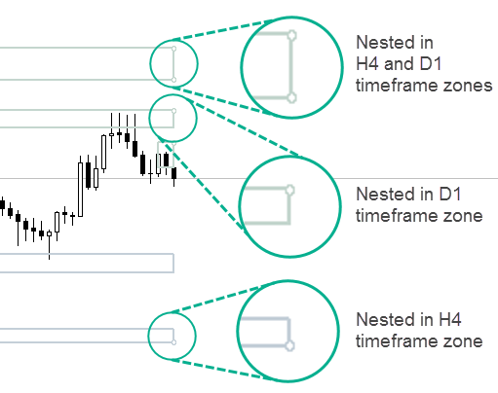
- Flip Prices
Change draw order of high and low prices so one is visible (This switch only works when “chart on foreground” is selected)
Hot-key: This can be changed without bringing up the parameters with “F” key
- Zone Style Invert
Change line zones to solid zones and vice versa. When in Solo mode this simply changes the zones from hollow to solid. In the multi-timeframe view timeframes 1 and 3 styles and/or colours will be swapped for an inverted effect. The behaviour can be controlled with the parameter “Zone Style Invert Mode” below
Hot-key: This can be changed without bringing up the parameters with “Z” key

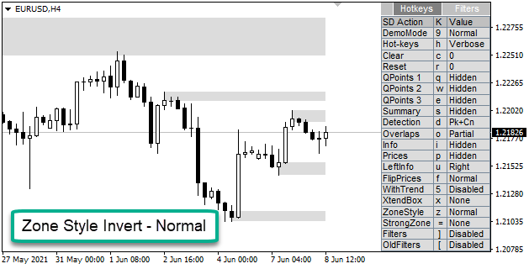

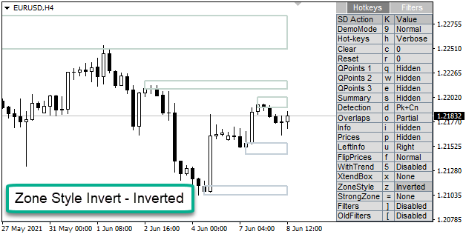

- Zone Visibility
Choose the visibility of the Supply Demand zones drawn on the chart
- Supplies and Demands
- Supplies
- Demands
- With Trend
- Counter Trend
- None

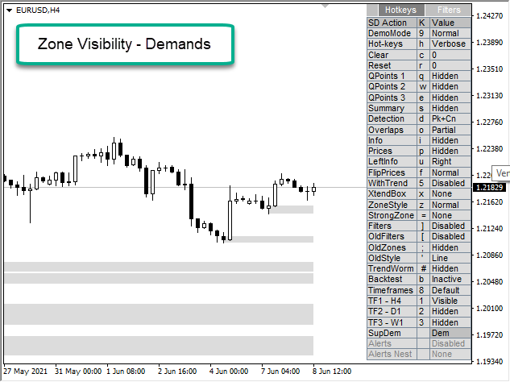

- Hot Keys Text Size
Set the text size for the Hot-key display dialog
- Hot Keys Map (English US)
Allows the user to re-assign the hot-keys
“H” Hot-Keys
“C” Clear
“R” Reset
“Q” QPoints
“S” Summary
“D” Detection
“O” Overlaps
“I” Info
“P” Prices
“U” Left Info
“F” Flip Prices
“W” With Trend
“X” Extend Box
“Z” Zone style Invert
“B” Backtest
“1” Timeframe 1
“2” Timeframe 2
“3” Timeframe 3
“9” Demo Mode
“=” Strong Zone
“]” Filters
“[” Old Filters
“;” Old Zones
“’” Old Zones - Style
“#” Nested Zones
“8” Extra Timeframes
- Hot Keys Map (English UK)
English UK version of the hot keys map
- Hot Keys Map (Other)
Other version of the hot keys map
- Hot Keys Reserved Keys
Define a list of keys that will stop clashes with hotkeys from other products
- Hot Keys Keyboard
Select the keyboard map (default Auto)
- Auto
- English US
- English UK
- Other
- Hot Keys Position
Select the location of the hotkey panel on the chart
- Top Left
- Top Right
- Bottom Left
- Bottom Right
- Hot Keys Panel X Offset
Set the position of the panel relative to the left side
- Hot Keys Panel Y Offset
Set the position of the panel relative to the bottom side
- Show Hotkey Tooltips
Enable/disable hotkey tooltips when hovering over the description column of the Hotkey panel

========== Strength Engine ==========
- Strong Zones Mode
Set mode for the minimum criteria of a strong zone
- Strict - Score, Move, Retouch, Risk Reward, Base, Clean Arrival, Hours
- Reduced - Score, Move, Retouch, Risk Reward
- Relaxed - Score
Hot-key: This can be changed without bringing up the parameters with “=” key
- Zone Highlight Mode
Set the way the zones are highlighted with normal / strong colours
- None – Do not highlight, all zones will be the weak colour
- Strength Score – Colour weak / strong as defined by the Strength Zones Mode above
- Untouched (Legacy) – Untouched will be strong colour and levels touched “Max Retouch” times will be weak colour
- Base Forming Hours
Valid business hours for strong level base consolidations. H1 and lower levels only
- Strong Levels – Score (0-8)
Score that must be attained before level is marked as strong (Default 6)
- Strong Levels – Max Retouch
Max times a level can be touched before being changed to weak (Default 1 – Second touch will change level to weak)
- Base Tolerance (Avg Bar Size)
Max percentage difference for two bar sizes to be considered a base
- Stop Loss Buffer (Avg Bar Size)
Size of buffer added to level when setting stop losses
- Initial Move Filter (Avg Bar Size)
Price movement away from the zone to qualify as a strong level
- Significant Move (Avg Bar Size)
Price movement away from zone needed to add second point to the score
- Clean Arrival (Avg Bar Size)
Minimum price difference between the zone and the first opposing level
- Base Num Candles
Number of similar sized candles to be considered as a base (Default 2)
- Base Extra Candle - Timeframe
Timeframe at which we require another candle to be added to be a valid base (Default H1)
- Base Extra Candle – Additional Tolerance
Additional tolerance for the base detection when we have extra candles
- Base Tolerance - Consolidation
Max percentage difference for two bar sizes to be considered a consolidation

========== Visibility Filters ==========
- Filters
Activate/Deactivate visibility filters that hide levels on the chart
Hot-key: This can be changed without bringing up the parameters with “]” key
- Filter - strength (0-8)
Only display levels with a score greater than or equal to this value
- Filter - Risk Reward
Only display levels with a Risk Reward greater than or equal to this value
- Filter - Min Bars
Only display levels with more bars than this value
- Filter - Max Bars
Only display levels with fewer bars than this value
- Filter - Max Levels
Restrict the number of Supplies or Demands zones displayed on the chart. Default 0
- Filter - Max Touches
Only display levels with fewer touches than this value
- Filters - Strong Only
Only display strong levels
- Filters - Engulfing Only
Only display levels that are formed with an engulfing candle
- Filter - Nested Levels
Only display levels that are nested within higher timeframe levels
- None – No filter
- Nested within 2nd timeframe level
- Nested within 3rd timeframe level
- Nested within 2nd or 3rd timeframe levels (Any)
- Nested within 1st and 2nd higher timeframe level (Both)
- Filter - Wick Size (Avg Bar Size)
Only display levels with wicks smaller than this value
- Filter – Zone Size (Avg Bar Size)
Only display levels with zone size smaller than this value
- Filter – Overall Move (Avg Bar Size)
Only display levels with overall move greater than this value
- Filter – Initial Move (Avg Bar Size)
Only display levels with initial move greater than this value
- Filter – Min Price Away
Only display levels further away than this distance from the current close price
- Filter – Max Price Away
Only display levels up to this distance from the current close price

========== Old Zones ==========
- Old Zones - Mode
Display Old Zones on the chart
- Hidden
- Broken Levels
- Trend Levels
- Actual Trend Changes
Hot-key: This can be changed without bringing up the parameters with “;” key

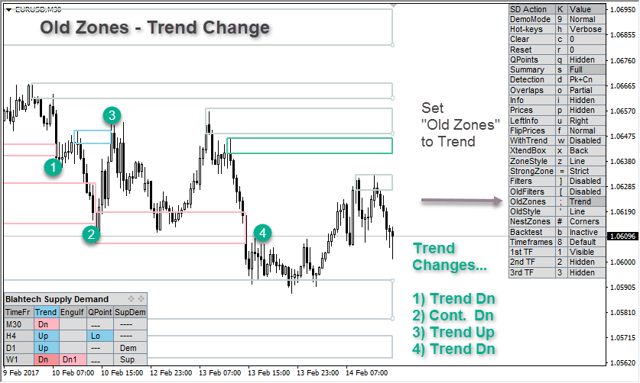

- Old Zones - Style
Set the drawing style of the old zones
- Line Style – No Extensions
- Line Style – With Extensions
- Line Style – Dotted Extensions
- Inherited Style – No Extensions
- Inherited Style – With Extensions
- Inherited Style – Dotted Extensions
Hot-key: This can be changed without bringing up the parameters with the single quotes “’” key
- Old Zones - Filters
Activate/Deactivate visibility filters that hide levels on the chart
Hot-key: This can be changed without bringing up the parameters with “[” key
- Old Zones - Filter - Strength (0-8)
Only display levels with a score greater than or equal to this value
- Old Zones - Filter - Risk Reward
Only display levels with a Risk Reward greater than or equal to this value
- Old Zones - Filter - Min Bars
Only display levels with more bars than this value
- Old Zones - Filter - Max Bars
Only display levels with fewer bars than this value
- Old Zones - Filter – Age Bars
Only display levels that were created further back than this number of bars
- Old Zones - Filter - Max Touches
Only display levels with more touches than this value
- Old Zones - Filter - Strong Only
Only display strong levels
- Old Zones - Filter – Engulfing Only
Only display levels that are formed with an engulfing candle
- Old Zones - Filter - Wick Size (Avg Bar Size)
Only display levels with wicks smaller than this value
- Old Zones - Filter – Zone Size (Avg Bar Size)
Only display levels with zone size smaller than this value
- Old Zones - Filter – Overall Move (Avg Bar Size)
Only display levels with overall move greater than this value
- Old Zones - Filter - Initial Move (Avg Bar Size)
Only display levels with initial move greater than this value
- Old Zones - Filter – Min Price Away
Only display levels further away than this distance from the current close price
- Old Zones - Filter – Max Price Away
Only display levels up to this distance from the current close price
- Old Zones - Broken - Supply Colour - Strong
Colour for the strong broken old levels
- Old Zones - Broken - Supply Colour - Weak
Colour for the weak broken old levels
- Old Zones - Broken - Demand Colour - Strong
Colour for the strong broken old levels
- Old Zones - Broken - Demand Colour - Weak
Colour for the weak broken old levels
- Old Zones - Broken – Show Extensions for Bars Since Exit
Maximum number of bars back that broken levels will show extended zones
- Old Zones – Trend – Supply Colour (Trend Up)
Colour for the old supply levels that changed the trend upwards
- Old Zones – Trend – Demand Colour (Trend Down)
Colour for the old demand levels that changed the trend downwards

==============Alerts ===============
- Action - Popup
Enable/Disable sound and/or popup dialog for active alerts
- Disabled
- Sound Only
- Popup and Sound
- Action - Email
Enable/disable email for active alerts
- Action - Notification
Enable/disable notifications for active alerts
- Levels - Broken
Trigger alerts when levels are broken
- Levels - Touches
Trigger alerts when levels are touched
- Levels – New Zones
Trigger alerts when new levels are created
- Alerts - Trends - Trend Change
Trigger alerts when Trend changes
- Alerts - Trends – Overall Trend Change
Trigger alerts when Overall Trend changes
- QPoints – Broken
Trigger alerts when QPoints are broken
- QPoints – Touches
Trigger alerts when QPoints are touched
- Alerts - Engulfings
Trigger alerts when bullish or bearish engulfings are detected
- Alerts - Timeframes - Levels
Comma separated list of timeframes that trigger alerts 1, 2 ,3 M30,H4,D1
- Alerts - Timeframes - Trends
Comma separated list of timeframes that trigger alerts 1, 2 ,3 M30,H4,D1
- Alerts - Timeframes - QPoints
Comma separated list of timeframes that trigger alerts 1, 2 ,3 M30,H4,D1
- Alerts - Timeframes - Engulfings
Comma separated list of timeframes that trigger alerts 1, 2 ,3 M30,H4,D1
- Filter Mode (Levels)
Choose to filter levels that trigger alerts
- No Filters
- Match Active Visibility Filters
- Always Apply Visibility Filters (even if inactive)
- Filter Mode (Levels)
Only trigger alerts for levels that are nested within higher timeframe levels
- None – No filter
- Nested within 2nd timeframe level
- Nested within 3rd timeframe level
- Nested within 2nd or 3rd timeframe levels (Any)
- Nested within 1st and 2nd higher timeframe level (Both)
- Zone Visibility
Set the Supply Demand zones that can trigger alerts
- Match Chart Zone Visibility
- Supplies and Demands
- Supplies
- Demands
- With Trend
- Counter Trend
- Sound Wav File
Set the wav file to be used for alerts
- Trigger Early (Points)
Trigger alerts a number of points before the price reaches the level. The user will receive alerts in advance of the level being touched or broken and may allow more time for decision making
- Startup Delay Seconds
Delay a number of seconds at startup before testing for alerts
- Max New Alerts
Restrict number of New alerts that can be raised at any one time per timeframe
- Message Text
Configure the popup and notification alert message text
- Email Subject
Configure the email alert subject
- Email Body
Configure the email alert body

========== Other Parameters ==========
- Instance Id
Unique Id (only modify if you need to use multiple instances per chart)
- High Low Deviation (Points)
Number of points beyond a level that need to be exceeded to break the level (Default 1)
The default setup of 1 point means the price must reach 2 points above the peak price to break the level
This allows older zones to persist if newer peaks are only one point above them. If newer zones are favoured then this value can be changed to zero
- Touch Deviation (Points)
Number of points beyond a level that need to be reached for a touch to be triggered (Default 1)
- Untouch Deviation (Points)
Number of points the next bar has to retrace from the touch trigger price to become untouched (Default 2)
The touch trigger price includes the touch deviation points, so the default setup is one point above the conterminous price to touch and one point below the conterminous price to untouch
- Zone Gap Deviation (Points)
Minimum number of points between levels (Default 0)
- Risk Percent (Lot size Calculation)
Percentage of Equity to be used when calculating the lot size for the level
- Adjust Start Bar Back
Draw Start of Zone back one or more bars from the peak bar
- Adjust Back None
- Adjust Back One – Draw back one bar if the conterminous line originates there
- Adjust Back Consolidation – Draw back one or more bars when there is a consolidation
- Adjust Back One Or Consolidation – Draw back one bar to conterminous or more with a consolidation
- Zone Height Type
- Standard – Zones adjusted by size of origin and second candle bodies
- Whole Body – From top wick to bottom body of the origin candle
- Entire Candle – From top wick to bottom wick of the origin candle
- Zone Height When Minimum/Fixed
Set the zone height when Zone Height Type is Minimum or Fixed
- Backtest Mode
Enable/Disable backtest mode
- Backtest Date
Set the date for the backtest
- Backtest Mode Expire Time (mins)
Set the number of minutes to wait before cancelling backtest mode (0 = no limit) (Default 30)
- Min Bars For Old Zones
Set the minimum number of candles for Old Zones to be created
- Max Bars – Old Zones and Trends
Restrict the number of bars to use for Old Zones and Trend calculations (Default 10000)
- Nested Zones Point Size (Avg Bar Size)
Set the size of the Nested Zones oval at the corners of the levels
- Info Score Mode
- Text
- Bubble Solid (default)
- Bubble Hollow
- Info Score Size
Set the size of Wingdings font used to display the bubble scores
- Info Text Size
Set the size of the information text displayed next to each level
- Info Text Colour
Set the colour of the information text
- Info Text Font
Set the font for the information text
- Info Lots Precision
Set a custom number of decimal points for the default lot size {lots1} (Default 1 decimal place)
- Info Custom Format
Configure your own text to be displayed next to each level when the Hot Keys / Info Text “Custom 1” option is selected.
The following substitution variables can be interspersed with your own text
{bar} - Bar Num
{high} - High Price
{low} - Low Price
{date} - Zone formation date
{time} - Zone formation time
{type}{typeLong} - Type of level (peak, consolidation, drop-base-drop)
{size0} {size1}{size2} - Zone size in user ticks (choice of three precisions)
{lots0}{lots1}{lots2}{lots3} - Lot size of level including buffer for risk percent (choice of four precisions)
{score} - Strength engine - score / max score e.g. 6/8
{scr} - Strength engine - score e.g. 6
{sA} - Number of Base Candles
{sB} - Has Valid Base (b= YES n=NO)
{sC} - Number of touches
{sD} - Is Within Trading hours (i=YES n= NO)
{sE} - Initial Move
{sEg} - IsEngulf (e=YES n=NO)
{sF} - Is Clean Arrival (c=YES n=NO)
{sG0}{sG1}{sG2} - Risk Reward Ratio (3 precisions)
{sH} - Is Within Trading Hours (h=YES n=NO)
{sM} - Total Move (Ticks)
{avgSize0} {avgSize1} {avgSize2} - Average size of candles at time of formation (3 precisions)
{lf} - Line feed
- Info Custom Format 2
Configure your own text to be displayed next to each level when the Hot Keys / Info Text “Custom 2” option is selected
- Tooltips
Choose the information to be displayed in the tooltips when the mouse hovers at the edge of the level
- Hidden
- High + Score + Low
- High + Score Size Lots + Low
- High + Score Size Lots Scoring AvgSize + Low
- High + Date + Score + Low
- High + Date + Score Size Lots + Low
- High + Date + Score Size Lots Scoring AvgSize + Low
- Custom – User defined string with substitutions
- Tooltips Custom Format
Configure your own tooltip to be hovered next to each level when the “custom” tooltip option is selected
See “Info Custom Format” above for substitution variables that can be interspersed with your own text
- Zone Style Invert Mode
Select the behaviour of the zone style invert hotkey
- Swap/Invert line style of solo zones only
- Swap solo line style + Swap line styles of zone 1 with zone 3
- Swap solo line style + Swap line style and colours of zone 1 with zone 3
- Timeframe Plus One Map
When Timeframe is set to “Timeframe Plus One/Two/Three” - Lookup the next timeframe using the current
timeframe as a key. When Plus “Timeframe Plus Two/Three” are selected the map will be de-referenced two
or three times
- Offline Chart Prefix
This parameter helps users use offline charts that have missing market data. If your offline chart has a name of “MYCHARTEURUSD” and is missing some Market Info data, you should set this parameter to “MYCHART” and the system will get the Market Info from the underlying “EURUSD”
- Clear Hotkeys On Chart Delete
Reset all hotkey settings when chart is deleted. We recommend MT4 users leave this set to true because
MetaTrader reuses window ids between different charts when profiles are changed. If you don’t clear the
hotkey settings MT4 users may see invalid configurations when switching profiles
- Clear Hotkeys On Terminal Close
Reset all hotkey settings when the terminal is closed. The default is false so the user can restore state when
restarting the terminal.
MT5 currently has a platform issue where it’s not possible to detect the difference between Terminal close
and switching Profiles. For users on MT5 that wish to clear hotkeys when switching Profiles, we
recommend setting this parameter to true for a more consistent Profile switching experience
- Show Buffers In Data Window
Show or Hide the iCustom Buffers in the Data window
- GMT Offset – Use Daylight Savings
Adjust the time by 1 hour if your local computer has switched to daylight savings mode. For brokers that switch their clocks in March/September
- GMT Offset
Manual GMT offset in seconds. Set this if your chart time doesn’t match your expectations of the current session time.

Developers - iCustom buffers
- Empty
- Changed
- SupBarNum
- SupHigh
- SupLow
- SupScore
- SupStrong
- QTop1Bar
- DemBarNum
- DemHigh
- DemLow
- DemScore
- DemStrong
- QBot1Bar
- OverallTrend
- Trend1
- Engulfing1
- QTop1
- QBottom1
- SupDemHint1
- Trend2
- Engulfing2
- QTop2
- QBottom2
- SupDemHint2
- Trend3
- Engulfing3
- QTop3
- QBottom3
- SupBarNum2
- SupLow2
- DemBarNum2
- DemHigh2
- SupBarNum3
- SupLow3
- DemBarNum3
- DemHigh3

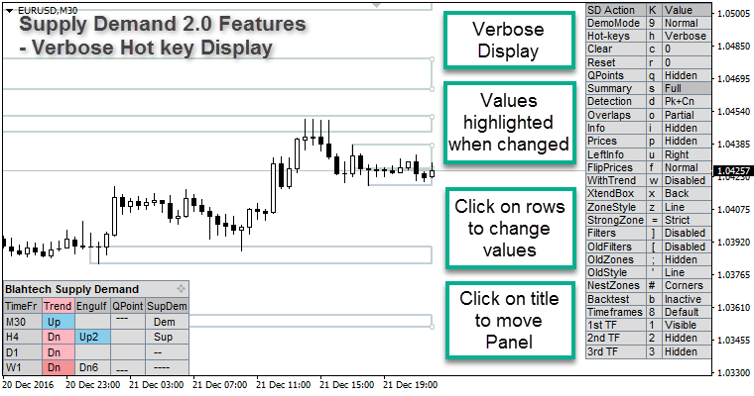

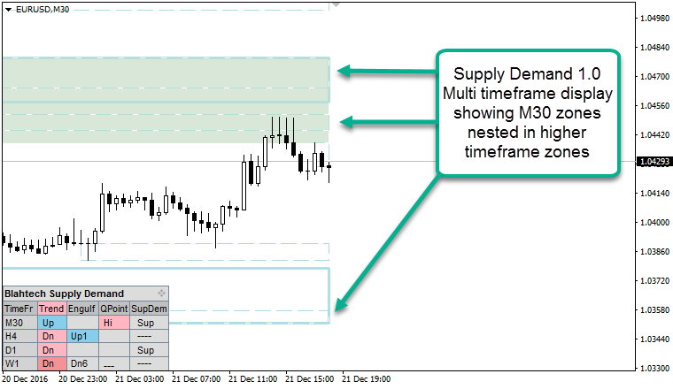

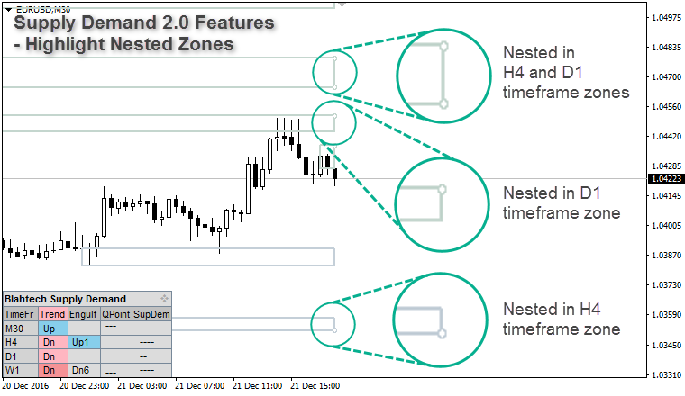

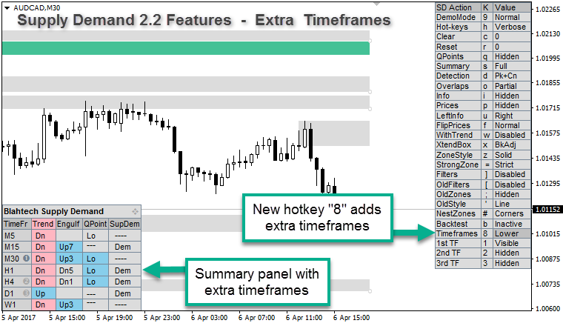

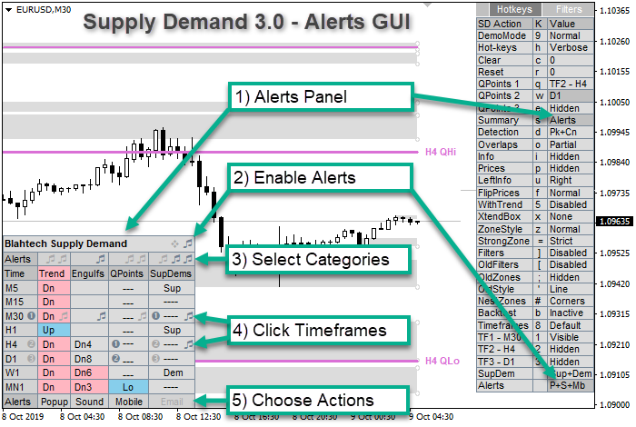



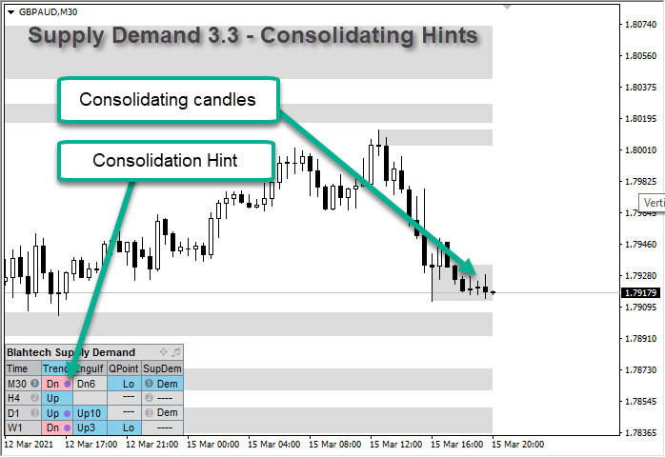

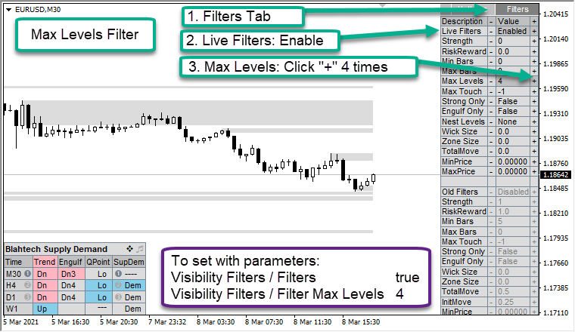

- Trend Change – Overall Trend Method
- "Two Adjacent"
- "Best Of Three"

